

|  |
| --- |
| **BATCH AND ROLL NO: R6 - 42257** |
| **EXPERIMENT NO.5** |
| **TITLE:** Design a mobile application to create different dialog boxes and menu Popup, option context. |
| **DATE OF PERFORMANCE** |
| **DATE OF CHECKING** |

**Title:** Design a mobile application to create different dialog boxes and menu Popup, option context.

# Requirements:

1. Android Studio Theory:

In android, the Menu is an important part of the UI component which is used to provide some common functionality around the application. With the help of the menu, users can experience smooth and consistent experiences throughout the application.

In Android, we have three types of Menus available to define a set of options and actions in our android applications.

The Menus in android applications are the following:

* Android Options Menu: Android Options Menu is a primary collection of menu items in an android application and is useful for actions that have a global impact on the search application.
* Android Context Menu: Android Context Menu is a floating menu that only appears when the user clicks for a long time on an element and is useful for elements that affect the selected content or context frame.
* Android Popup Menu: Android Popup Menu displays a list of items in a vertical list which presents the view that invoked the menu and is useful to provide an overflow of actions related to specific content.

Steps for Option Menu

1. Create a New project in Android Studio
2. Working with the XML Files, go to the **activity_main.xml file**, which represents the UI of the project. Make the code for the **activity_main.xml** file according to your requirements.
3. Create Menu Directory and Menu File-First we will create a menu director which will contain the menu file. Go to app > res> right-click > New > Android Resource Directory and give the Directory name and Resource type as menu. WE will create a popup menu file inside that menu resource directory. Go to app > res > menu>right-click> New> Menu Resource File and create a menu resource file and name it popup-Menu. In the popup_mennu file, we will add menu item.



# Code:

**Activity_main.xml**

<?xml version="1.0" encoding="utf-8"?>

<LinearLayout xmlns:android="<http://schemas.android.com/apk/res/android>" android:layout_width="match_parent" android:layout_height="match_parent"

android:orientation="vertical">

<EditText android:id="@+id/dialog_box_content_edit_text" android:layout_width="match_parent" android:layout_height="wrap_content" android:hint="Enter dialog box content" />

<RadioGroup android:id="@+id/dialog_box_type_radio_group" android:layout_width="match_parent" android:layout_height="wrap_content" android:orientation="vertical">

<RadioButton android:id="@+id/alert_dialog_box_radio_button" android:layout_width="match_parent" android:layout_height="wrap_content" android:text="Alert Dialog Box" />

<RadioButton android:id="@+id/confirm_dialog_box_radio_button" android:layout_width="match_parent" android:layout_height="wrap_content" android:text="Confirm Dialog Box" />

<RadioButton android:id="@+id/prompt_dialog_box_radio_button" android:layout_width="match_parent" android:layout_height="wrap_content" android:text="Prompt Dialog Box" />

<RadioButton android:id="@+id/custom_dialog_box_radio_button" android:layout_width="match_parent" android:layout_height="wrap_content" android:text="Custom Dialog Box" />

</RadioGroup>

<Button

android:id="@+id/preview_dialog_box_btn" android:layout_width="match_parent" android:layout_height="wrap_content" android:text="Preview" />

</LinearLayout>



# Activity_dialog_creator.xml

<?xml version="1.0" encoding="utf-8"?>

<LinearLayout xmlns:android="<http://schemas.android.com/apk/res/android>" android:layout_width="match_parent" android:layout_height="match_parent"

android:orientation="vertical">

<EditText android:id="@+id/dialog_box_content_edit_text" android:layout_width="match_parent" android:layout_height="wrap_content" android:hint="Enter dialog box content" />

<RadioGroup android:id="@+id/dialog_box_type_radio_group" android:layout_width="match_parent" android:layout_height="wrap_content" android:orientation="vertical">

<RadioButton android:id="@+id/alert_dialog_box_radio_button" android:layout_width="match_parent" android:layout_height="wrap_content" android:text="Alert Dialog Box" />

<RadioButton android:id="@+id/confirm_dialog_box_radio_button" android:layout_width="match_parent" android:layout_height="wrap_content" android:text="Confirm Dialog Box" />

<RadioButton android:id="@+id/prompt_dialog_box_radio_button" android:layout_width="match_parent" android:layout_height="wrap_content" android:text="Prompt Dialog Box" />

<RadioButton android:id="@+id/custom_dialog_box_radio_button" android:layout_width="match_parent" android:layout_height="wrap_content" android:text="Custom Dialog Box" />

</RadioGroup>

<Button

android:id="@+id/preview_dialog_box_btn" android:layout_width="match_parent" android:layout_height="wrap_content" android:text="Preview" />

</LinearLayout>



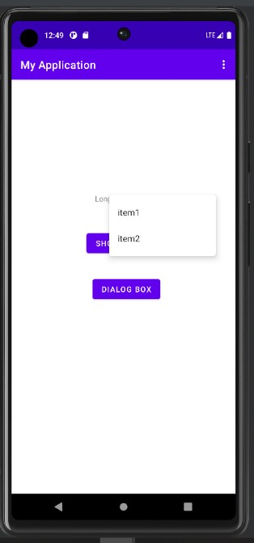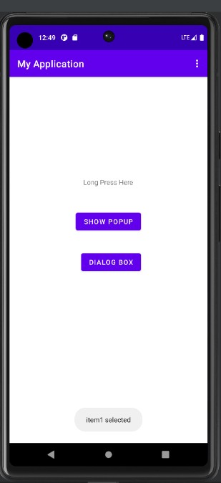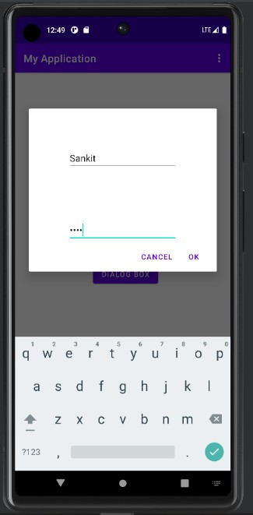

# Output:

**CONCLUSION:**

# ……………………………………………………………………………………………

**……………………………………………………………………………………………**

# ……………………………………………………………………………………………